**Bluff Lake Project Equipment**

Electronics:

* Trail Cameras
  + Location: We have five functional cameras which are deployed around Bluff Lake.
    - Cameras are located on bridges, notches, and the reservoir intake structure
  + Battery life and card memory should cover up to two months without replacement
* Hobo Level loggers
  + Location: We have four level loggers deployed within and around Bluff Lake
    - Loggers are located on the visitor center deck, the cypress boardwalk, the small control structure on the eastern levee, and the intake structure in the northeastern portion of the reservoir
* HOBO temp loggers, readout devices, adapters, manuals and related items
  + Location: In red duffel-will be returned to Colvin before departure
* YSI meter
  + Location: In black duffel-will be returned to Colvin before departure
    - Sensor should be kept wet. If using, emphasize the importance of not letting the black membrane dry out. If in storage (even overnight), place a wet sponge in the red cover and place over the sensor. If in long term storage check sponge every few months.
* Humminbird Fish-finder
  + Location: In shop. Sonar bulb is attached to mount and the fish finder is in the connected light-yellow toolbox.
* 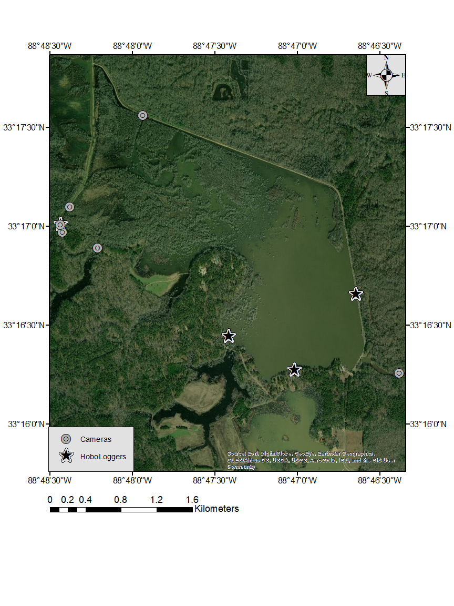

Figure 1 Map of Hobo level logger and camera deployment locations near Bluff Lake, MS from 2019-2020. Cameras are represented by grey circles; Hobo level loggers are represented by black stars.

Sampling gears:

* Fykes and hoop nets
  + Location: Miranda’s fykes have been returned to his shop, our fykes and hoops are in our shop, additional hoop nets are located in the shared metal shop.
    - All fykes were in good condition when last inspected
    - Extra Zote soap/bait in shop
* Experimental Gillnets
  + Location: White feed sacks, bags should be labeled with condition.
    - We have one NEW net and two to three other nets in good condition
* Trotlines
  + Location: good lines are wrapped around 5 gallon buckets, poor condition lines are in a red milk crate (parts could be salvaged for other projects).
* Tagging guns and tags
  + Location: Orange toolbox
* Light and Dark bottles
  + Location: Returned to fish lab